# FUNAI Logo

# DEPARTMENT: BANKING AND FINANCE

# GROUP:

# BUS 102 ASSIGNMENT

# TITLE:

# BY

# LECTURE OYIMS

# COURSE CODE: BUS 102

**NAME**: **DAVID MIRACLE ENUWOLE**

**REG NUM:**

# REG NUM:

# DATE:

**Topic: THE NATURE OF COMPANY ORGANIZATIONS**

# INTRODUCTION

This chapter offers a broad definition of a company organization. Systems perspectives to managing change within organizations, namely the systems approach, the contingency approach, and learning organizations are discussed. The characteristics and components of organizational systems, organizational behaviour, and the characteristics of successful organizations are also discussed.

# DEFINITIONS OF A COMPANY ORGANIZATION

According to Gibson, Ivancevich and Donnelly (2000:5) “organizations are entities that enable society to pursue accomplishments that can’t be achieved by individuals acting alone”.

Greenberg and Baron (2000:4) and Robbins (1998:2) define organizations as structured social systems consisting of individuals and groups working together on a relatively continuous basis to attain a common goal or set of goals.

# 2.3 THE COMPANY ORGANIZATION AS AN OPEN SYSTEM

According to Gibson et al. (2000:14) an organizational system is a grouping of elements that interact with each other and their environment, both as individuals and collectively. Systems theory enables the description of behavior of individuals, groups and organizations both internally and externally. Due to the interaction between elements of a system and their interdependence, a change in one part of an organization system has consequences for other parts of the organization, and its environment (Ivancevich and Matteson, 1999:23).

The flow of inputs and outputs is a basic starting point in the description of the system (see Figure 2.1). A system contains three basic elements, viz. inputs, information processing and outputs (Luthans, 1998:531). Inputs contain all the resources, information and energy applicable to the processing function. Processes refer to all the activities and functions that are performed to produce products and services. Outputs are outcomes of the processing function, viz. the finalized products and services produced by the organization. In the light of this, the organization can be represented as an open system as shown in Figure 2.1.

According to Gerber et al. (1998:36) the reason for the existence of an organization lies in the needs present in the organization's external environment and the changes in those needs occurring over time. It is therefore essential that the organization should undertake effective scanning to identify opportunities and threats in its external environment and strengths and weaknesses in the internal environment and to formulate its strategy accordingly (Gerber et al., 1998:36). Organizations need to effectively receive, process, and act on information to be successful, and find the optimal fit between the external environment and the design of the transformation process (Luthans, 1998:531-532). The external success factors (input) are processed by the interdependent subsystems (internal infrastructure) of the organization. These internal success factors lead to the tangible and non-tangible outputs that subsequently determine organizational success. Organizational success is determined by the set objectives and standards and the feedback from all stakeholders on all outputs produced by the organization. The feedback should finally be evaluated and incorporated in the environmental scanning process as part of the input phase (Gerber et al., 1998:36). Organizational effectiveness, efficiency and success will be discussed in paragraph 2.6, while the characteristics and components of organizational systems are discussed next.

**THE ORGANIZATION AS AN OPEN SYSTEM**

**FIGURE 2.1:**

**.**

EFFECTIVENESS

EFFICIENCY

SUCCESS

EXTERNAL ENVIRONMENT

ORGANISATIONAL

ORGANISATIONAL PER

TRANSFORMATION

PROCESSES

FORMANCE STANDARDS

INPUT OUTPUTS

OWNER/ CONSUMER/ CUSTOMER INDEX

FEEDBACK

TESTING

EVALUATION

ORGANISATIONAL

SUCCESS

INTERNAL

INFRASTRUC-

TURE

•Goal and values

subsystem

•Psychosocial

subsystem

•Structural

subsystem

•Technological

subsystem

•Management

subsystem

TANGIBLE OUTPUTS

•Turnover

•Profit

•Return on investment

•Market share

•Performance

NON-TANGIBLE

OUTPUTS

•Morale

•Employee satisfaction

•Absenteeism

•Labourturnover

•Complaints/

grievances

•Theft

•Wastage

•Needs of the

community

•People(training/

experience/skills)

•Raw materials

primary

-

-

secondary

•Information

•Capital

•Existing

external

infrastructure

RE-EVALUATION

OF THE

EXTERNAL ENVIRONMENT

SATISFACTION/DISSATISFACTION

•Consumer/customer satisfaction

•Social responsibility

•Dividends

•Image of the organization

•Other

E

X

T

E

R

N

A

L

S

U

C

C

E

S

S

F

A

C

T

O

R

S

I

N

T

E

R

N

A

L

S

U

C

C

E

S

S

F

A

C

T

O

R

S

INPUTS

ENVIRON-

MENTAL

SCANNING

AND

STRATEGIC

PLANNING

EXTERNAL

ENVIRON-

MENT

(

Source: Adapted from Gerber

et al

., 1998:37)

## 2.3.1 THE CHARACTERISTICS AND COMPONENTS OF COMPANY ORGANIZATION

Organizations do not function as isolated components or parts. The components of the organization interact with each other and with the outside environment. The characteristics of an open system will be discussed next.

A system is composed of interrelated, interdependent parts called subsystems, and functions as an integrated whole, where change in one subsystem will evoke change in the others. Systems are goal seeking which implies that they are flexible and self-regulating and use feedback regarding performance and success to adapt (Harvey and Brown, 1996:37).

Organizations are open systems in constant interaction with their environment (Hellriegel et al., 2001:63). Harvey and Brown (1996:39-40) explains that the organization as an open

system consists of five interrelated primary components (subsystems), viz. the structural, the technical, the psychological, goals and values, and the managerial component. The structural subsystem contains the formal design, division of work, decision-making and authority, and organizational policies and procedures. The technical subsystem refers to the primary functions, activities and operations that include the technology, techniques and equipment necessary for production and output of the system. The psychosocial subsystem (culture) is human based and refers to the network of social relationships, behavioural patterns, norms, roles, and communications. The goals and values subsystem contains the basic mission and vision of the organization. Such goals might include profits, growth, or survival and are set after the environmental scanning process. The managerial subsystem spans the entire organization by directing, organizing and coordinating all activities toward the basic mission. The managerial subsystem is important for the integration of the other subsystems.

According to Ivancevich and Matteson (1999:24) systems theory emphasizes two important considerations, viz. organizational survival which is dependent on the ability of the organization to adapt to the demands of its environment, and management needs to understand and manage the cyclical process of input-processing-output-feedback.

# 2.4 THE CONTINGENCY APPROACH TO MANAGEMENT AND THE LEARNING ORGANIZATION

A contingency approach refers to differences in individual, group, organizational, environmental, and situational factors, which in combination with each other, influence behaviour in organizations (Baron and Greenberg, 2000:14). Although systems theory provides a conceptual overview of organizational functioning, management needs to know how the subsystems of a particular organization are uniquely related in that specific environment and how best to manage it in that environment. What constitutes effective management in one system or subsystem may not be so in another setting, especially in times of change.

The learning organization has evolved out of systems theory and the contingency approach to management. Learning organizations go beyond adapting to change; instead they anticipate and learn from change. In learning organizations learning and innovation is part of the organizational culture, with a sense of urgency to anticipate change and to learn from it (Luthans, 1998:50). Hellriegel et al. (2001:383-385) summarize the elements of a learning organization, viz. organizational culture, strategy, organizational design, and the use of information. Organizational culture in a learning organization is based on shared leadership, empowerment, and continuous learning. According to Brill and Worth (1997:151-152) effective organizations need a total quality-focused, flexible, and entrepreneurial culture. Organizational strategy should be aligned with the organizational culture, have a long-term perspective, and be customer focused. The organizational design of learning organizations are team-based, built on empowerment, cooperation, competence and responsibility. Learning organizations can use strategic alliances with customers, suppliers, and competitors as methods for learning. Information is used in the environment scanning process (described earlier), based on measurement criteria, and managed as a shared responsibility (Hellriegel

et al., 2001:383-385). .

# 2.5 ORGANIZATIONAL BEHAVIOUR

Baron and Greenberg (2000:4) define organizational behaviour as “the knowledge of all aspects of behavior in organizations through the use of scientific methods.” The understanding of organizational behaviour needs consideration and attention to be focused on

the structure of the organization, work and organizational processes, and behaviour of individuals and groups. A contingency approach implies the assessment of every subsystem including structure, technical functions and processes, organizational culture, goals and values, and the management function across the whole spectrum of the organization.

The basic organizational behaviour model refers to the impact that individuals, groups and structure have on attitudes and behaviour within an organization. This knowledge can be applied to make organizations work more effectively, improve job satisfaction, performance and productivity, improve work motivation, and reduce absenteeism and turnover.

The basic organizational behaviour model is presented in Figure 2.2.

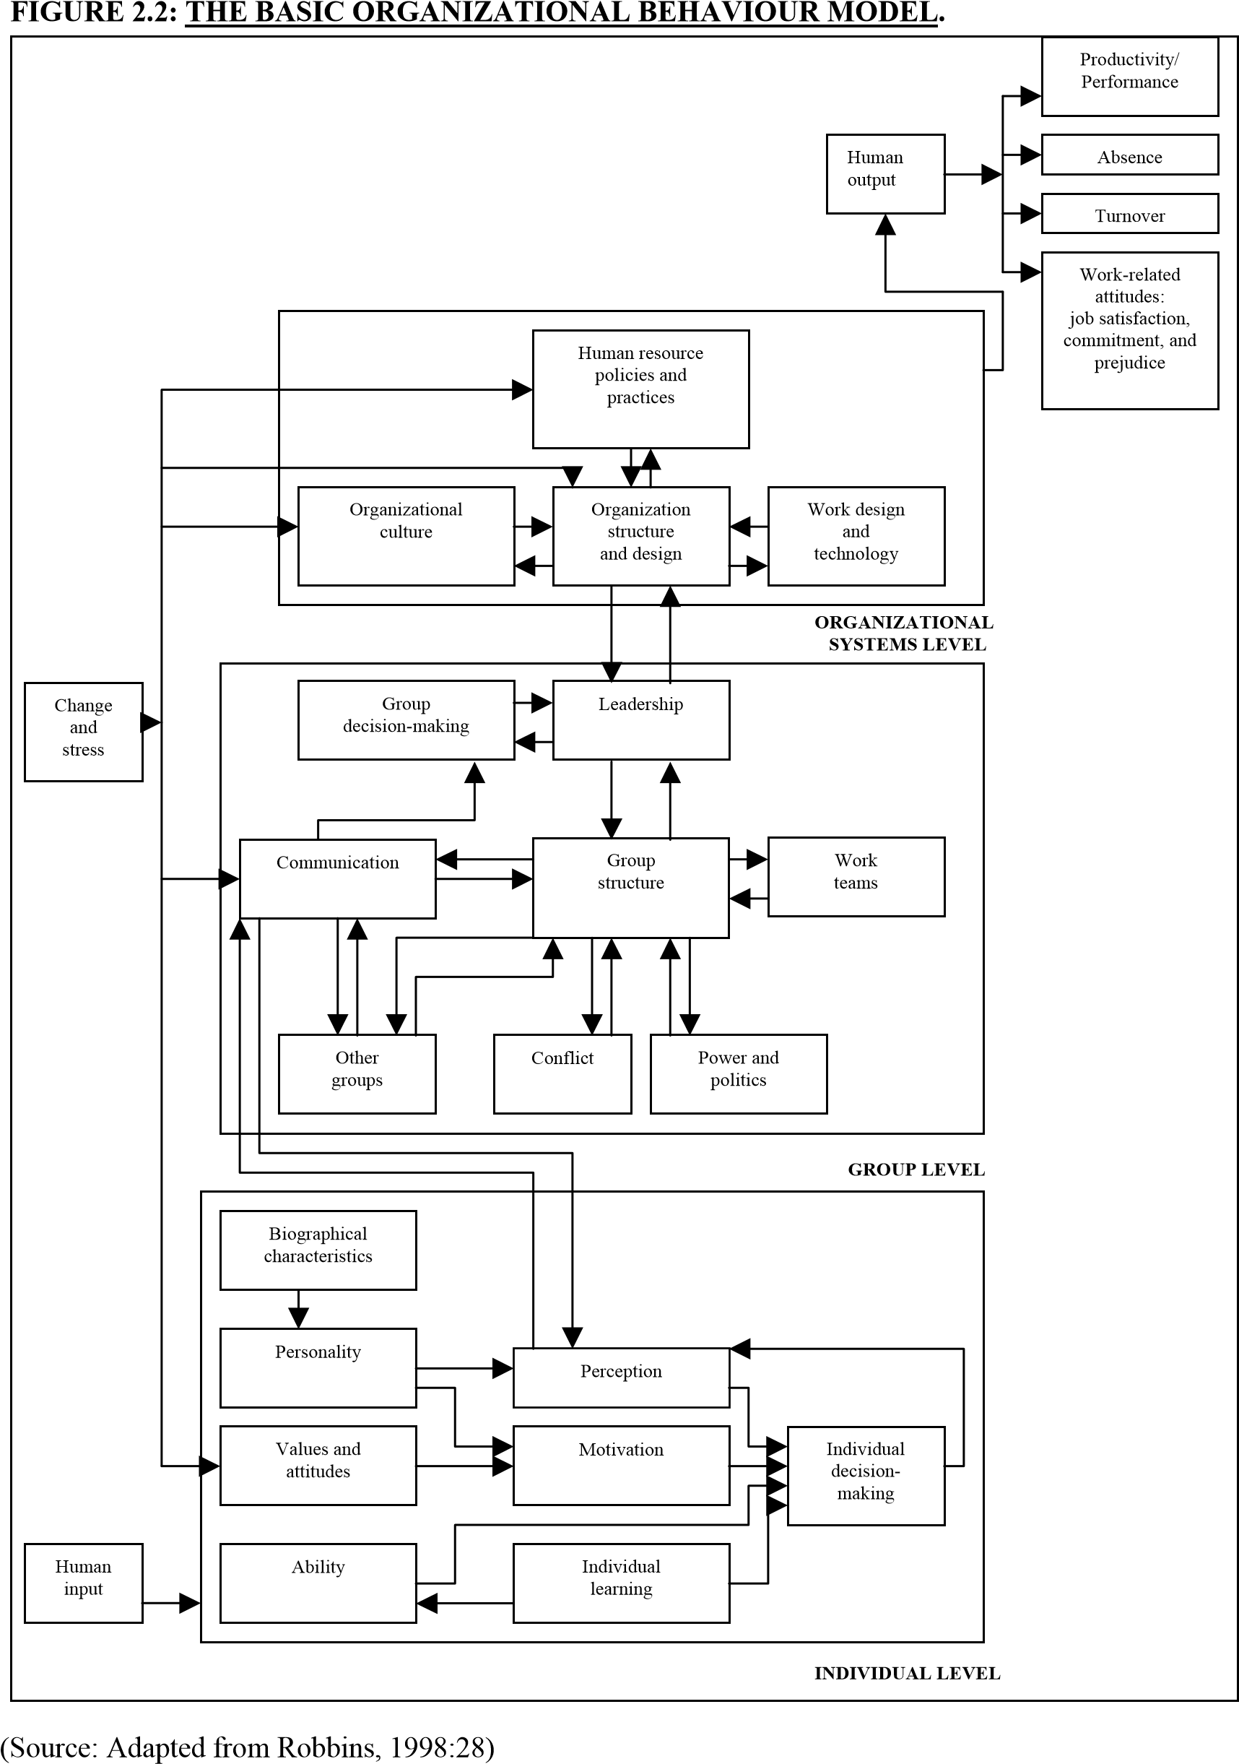

The organizational behaviour model in Figure 2.2 shows four human outputs namely productivity or performance, absence, turnover and work-related attitudes, which are the dependent variables. Robbins (1998:23-26) sees the dependent variables as the key factors organizations want to explain or predict and believes that they are affected by some other factors. Productivity, performance, absence, and turnover are all components of observable behaviour, and important dependent variables. Work-related feelings and attitudes like job satisfaction, organizational commitment, and prejudice (also important dependent variables) are not necessarily observable, but impact on organizational success. The dependent variables are influenced by the independent variables and are discussed next.

Individual-level variables are associated with the diversity components of people that will influence their behaviour at work. These characteristics are biographical, personality, values and attitudes, perceptions, competencies, individual learning abilities, and motivation. Grouplevel variables are associated with the behaviour of people in groups that differ from their behaviour when they’re alone. Norms of behaviour, the design and structure of work teams, communication, leadership styles, power and politics, intergroup relations, group decisionmaking and conflict affect group behaviour. Organization system level variables like organizational culture, the design and structure of the formal organization, work processes and technology, and human resource policies and practices all impact on the dependent variables. Work stress and change impact on the individual, group, and organizational levels and affect organizational behaviour and work-related attitudes (Robbins, 1998:27).

From Figure 2.2 it is evident that the independent variables at the individual, group and organizational levels are linked to one another. Organizational culture and structure are linked to leadership because authority and leadership are related and management influences group behaviour through leadership. Communication is the means by which information is transmitted and it is therefore the link between individual and group behaviour (Robbins, 1998:27).

The organizational behaviour model emphasizes individual differences, the link between the independent variables and the impact of change on all the variables (including subsystems) in an organization. It offers specific insights to improve human outputs related to performance, job satisfaction or motivation, absenteeism, turnover, and specific job-related attitudes.

# 2.6 ORGANIZATIONAL EFFECTIVENESS, EFFICIENCY, AND SUCCESS

From Figure 2.1 it is evident that organizational effectiveness, efficiency, and success are important considerations for organizations as open systems. Organizational effectiveness and efficiency on the individual, group, and organizational level will impact on organizational behaviour and success.

According to Bennett, Fadil and Greenwood (1994:474), the most effective practices for an organization demand a solid, consistent foundation of balanced values, strategy and culture, that will ensure the long-term effectiveness and performance of an organization. Successful organizations need vision and commitment to the core strategy and willingness to change where change is needed. Corporate culture is a key ingredient in the success of an organization because it can motivate employees to work together for organizational success (Case, 1996:42). Linking of the strategy to corporate culture and systems will lead to consistency and efficiency (Fitz-Enz, 1997:12).

According to Gibson et al. (2000:15) organizational effectiveness is caused by various factors, but is dependent on group effectiveness and individual effectiveness. Figure 2.3 depicts the perspectives, relationship and causes of effectiveness in organizations.

It is evident from Figure 2.3 that group effectiveness depends on individual effectiveness while organizational effectiveness depends on group effectiveness. According to Gibson

et al.(2000:15) the specific relationship depends on the type of organization, the products or services offered and the technology utilized. Some of the possible factors that cause or hamper effectiveness are listed in Figure 2.3.

**FIGURE 2.3:**

**THE CAUSES OF EFFECTIVENESS IN ORGANIZATIONS**

**.**

Individual

effectiveness

roup

G

effectiveness

rganisational

O

effectiveness

auses

C

bility

A

Skill

ledge

now

K

ttitude

A

otivation

M

Stress

auses

C

ohesiveness

C

Leadership

Structure

Status

R

oles

N

orm

s

C

auses

E

nvironm

ent

Technology

Strategy

Structure

Processes

ulture

C

(

Source: Gibson

et al

., 2000:15)

In order for organizations as open systems to be successful over the short, medium and longterm they need to focus on practices to achieve individual, group and organizational effectiveness, and should set measurable objectives and performance standards (Gerber et al., 1998:38). Ivancevich and Matteson (1999:26-29) agree with this view but propose that the following effectiveness criteria should be included, viz. quality and efficiency related to return on investment, cost, turnaround times, and down time. The authors subsequently focus on organizational, group, and individual adaptiveness, learning and development, and innovation that are vital for organizational success. Gerber et al. (1998:38) argue that an organization that pursues tangible outputs at the cost of the human element (quality of worklife) will only be successful in the short term.

# 2.7 CONCLUSION

This chapter discussed the nature of company organizations, which are open systems with interrelated and interdependent parts. Attention was also given to the view of organizations as open systems with certain characteristics and primary components that are in constant interaction with its environment. From the discussion it is evident that organizations are complex and unique in many ways and are constantly influenced by an accelerated rate of change and variables on individual, group and organizational level that impacts on organizational behaviour and success.

From the discussion it is evident that there is no “best way” to manage in all situations. A contingency approach should be followed which recognizes that differences in individual, group, organizational, environmental, and situational factors, all in combination with each other, influence attitudes and behaviour in organizations. What constitutes effective management in one system or subsystem may not be the case in another setting, situation or during change. Organizations should strive to become learning organizations, going beyond adapting to change, anticipating and learning from change, and subsequently being successful.